MongoDB Assignment 2

1. **Create a database named university and a collection named students. Insert multiple student documents with fields: name, age, department, and grades.**

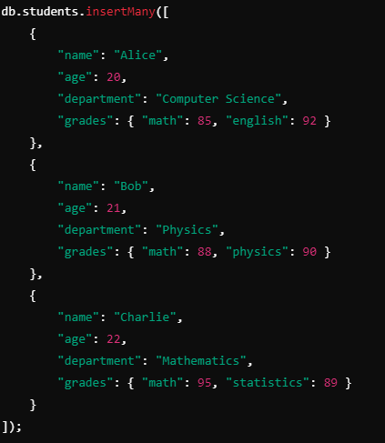

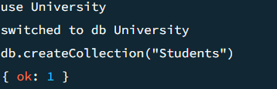

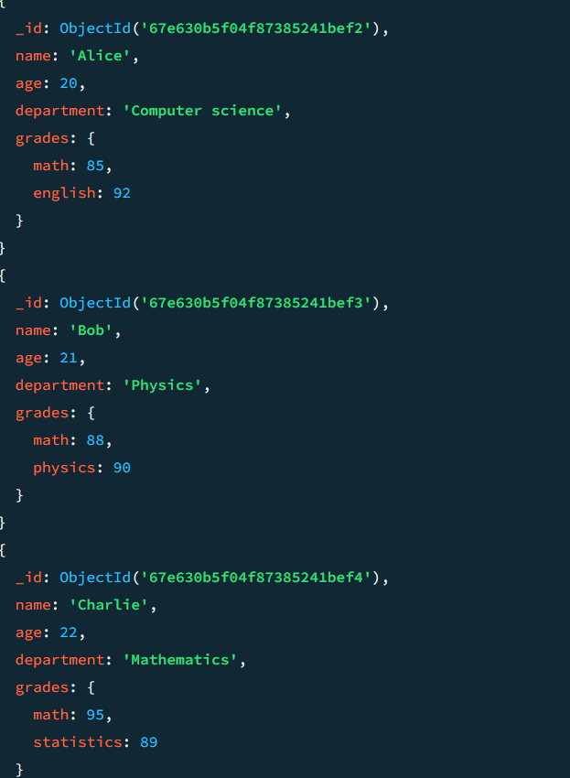

1. **Write a query to display all students who are in the Computer Science department.**

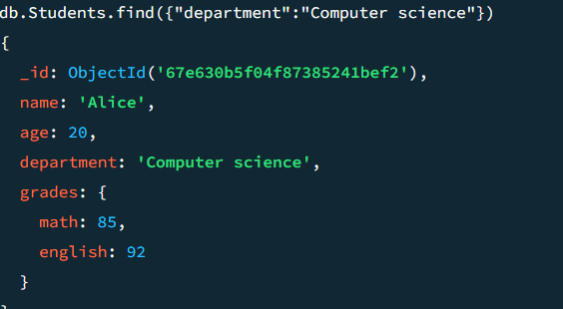

1. **Write a query to update the grades of a student named Alice by adding a new subject programming with a grade of 93.**

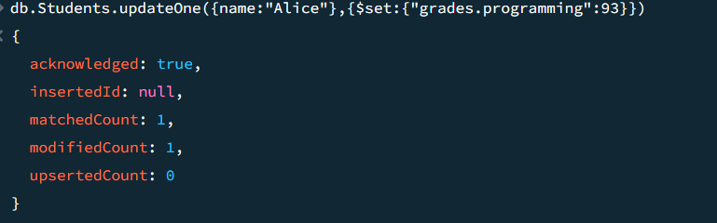

1. **Write a query to increment the age of all students by 1.**

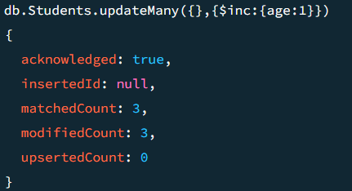

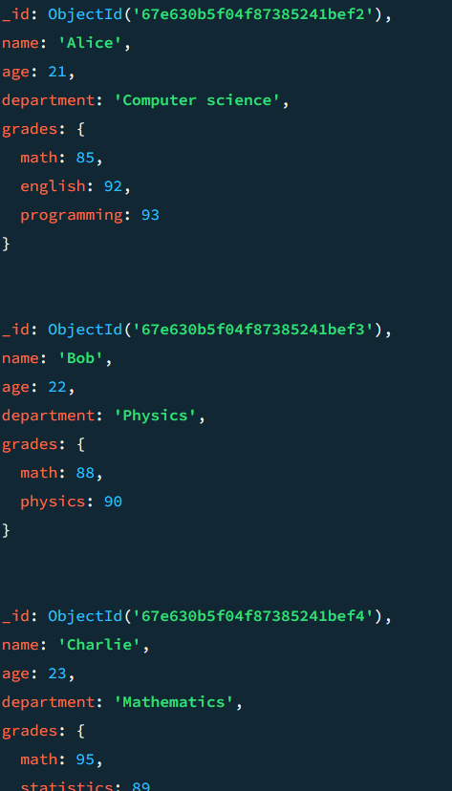

5**. Write a query to add a new field graduated set to false for all students who are in the Mathematics department.**

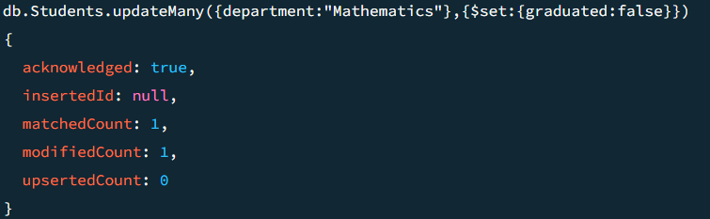

6. **Write a query to create an index on the name field of the students collection.**

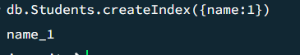

1. **Write an aggregation query to group students by their department and calculate the average age in each department.**

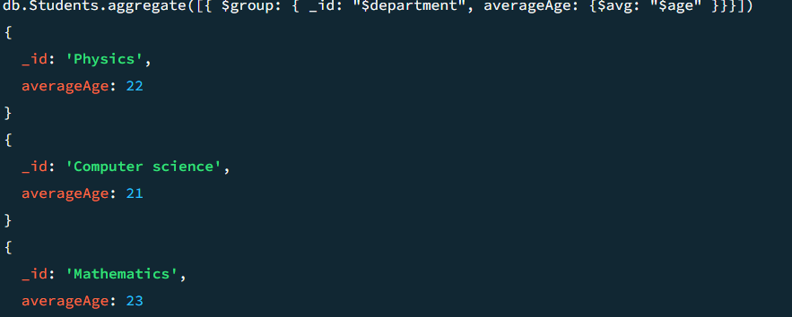

1. **Write a query to find all students who have scored more than 90 in any subject.**

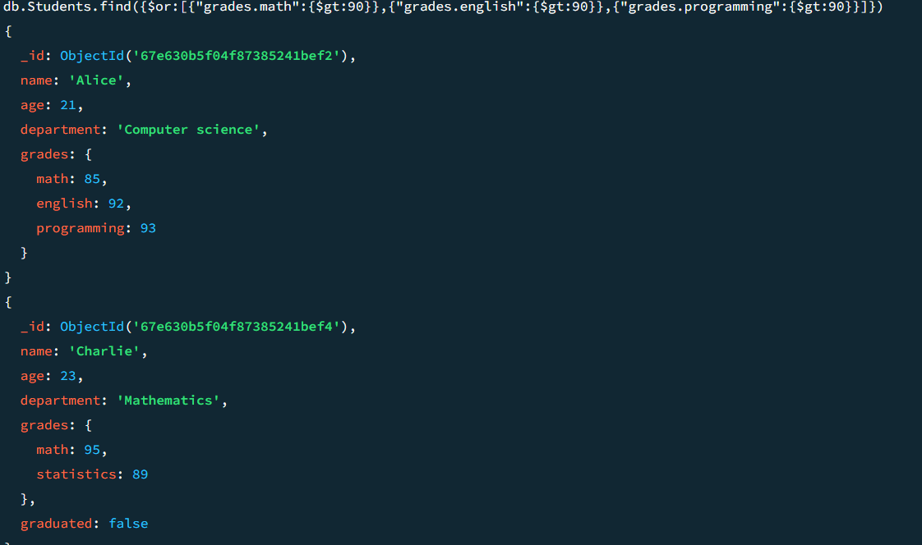

1. **Write a query to delete all students who are 23 years old**

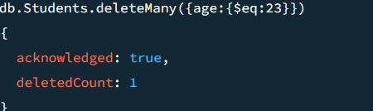

1. **How can you retrieve only the name and department fields for all students, excluding the _id field?**

